**Install custom software**

We have two approaches we can use to install software. First, this VM is connected to the internet. If the software you need has a downloadable installer, you can open a web browser in the RDP session, download the software, and install it. Second, if your software is custom, like our custom service, you can copy it from your local machine over to the VM to install it. Let's look at this latter approach.

1. Open File Explorer. In the sidebar, select **This PC**. You should see several drives:
   * Windows (C:) drive representing the OS.
   * Temporary Storage (D:) drive.
   * Your local C: drive (it will have a different name than the following screenshot).

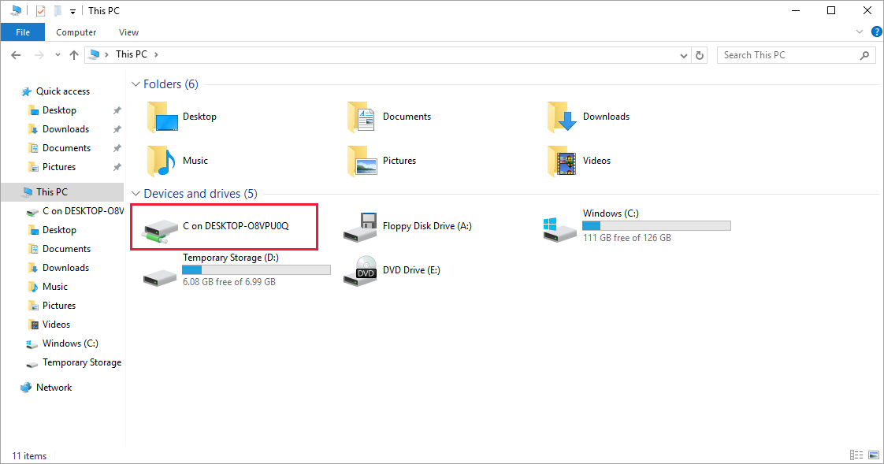

With access to your local drive, you can copy the files for the custom software onto the VM and install the software. We won't actually do that because it's just a simulated scenario, but you can imagine how it would work.

The more interesting thing to observe in the list of drives is what is *missing*. Notice that our **Data** drive is not present. Azure added a VHD but didn't initialize it.

**Initialize data disks**

Any additional drives you create from scratch will need to be initialized and formatted. The process for doing this is identical to a physical drive.

1. Launch the **Disk Management** tool from the **Start** menu. You may have to go to the **Computer Management** tool first, then **Disk Management**, or try searching for *Disk Management* in the **Start** Menu.
2. It will display a warning that it has detected an uninitialized disk.

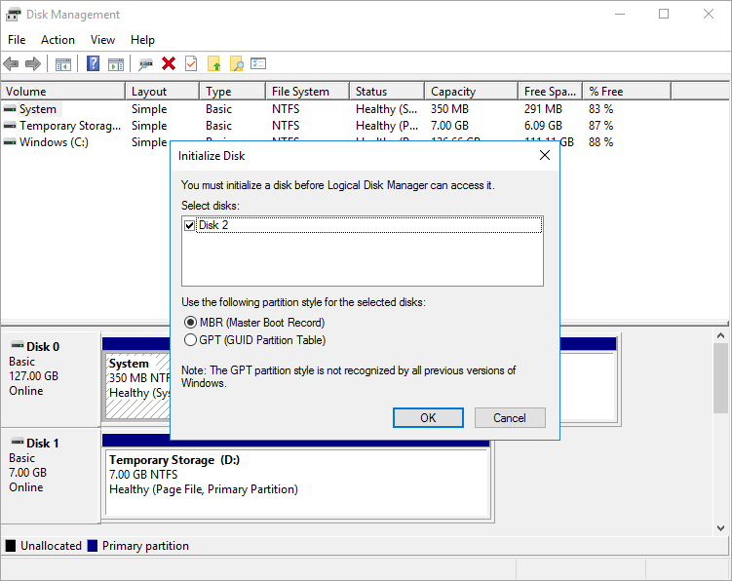

1. Select **OK** to initialize the disk. It will then appear in the list of volumes where you can format it and assign a drive letter.
2. Open File Explorer and you should now see your data drive.
3. Go ahead and close the RDP client to disconnect from the VM. The server will continue to run.

RDP allows you to work with the Azure VM just like a local computer. With Desktop UI access, you can administer this VM as you would any Windows computer: installing software, configuring roles, adjusting features and other common tasks. However, it's a manual process - if we always need to install some software, you might consider automating the process using scripting.